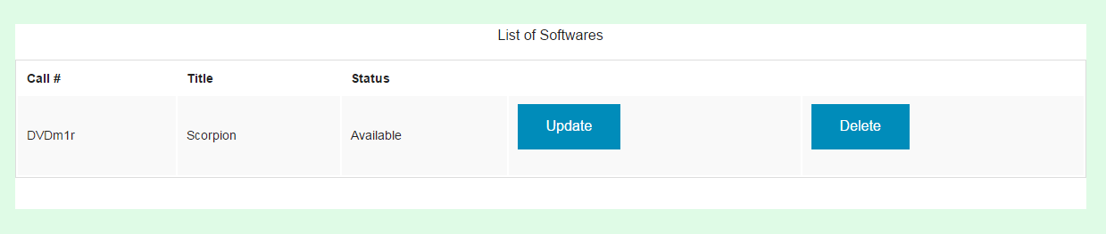

1. Call # Column
   * Description: This is where the staff views the software materials.
   * Action: None
2. Title Column
   * Description: This is where the staff views the title of the software.
   * Action: None.
3. Status Column
   * Description: This is where the staff views the status of the software.
   * Action: None
4. Update
   * Description: Button
   * Action: Change the row to a editable row
5. Delete
   * Description: Button
   * Action: Redirects to deleteSoftware.php to delete the software material